# Start-up

1. Go to the …/GSP/ProgramFiles/v4.2 in matlab
2. Run sysplotter.m, which is in …/GSP/ProgramFiles/v4.2
3. The first time you start it up, the following screen will appear. (if you want to get back to this screen, you can run sysplotter_config.m)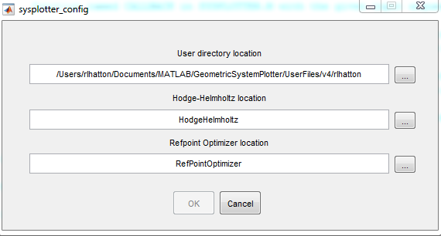
4. Use the first “...” box to select your user directory. You can use the GenericUser directory in UserFiles/v4/, but we recommend that you make a copy of this directory with your name and work in the copy. (This lets you share your work environment with someone else by simply giving them your user folder).
5. This dialog checks to make sure that you have selected a user folder with the necessary subfolders, then lets you click “OK” 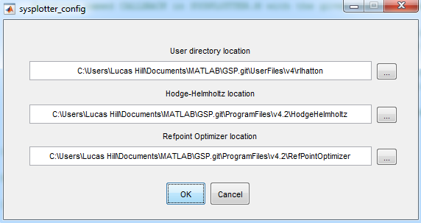
6. Your screen should now display the sysplotter 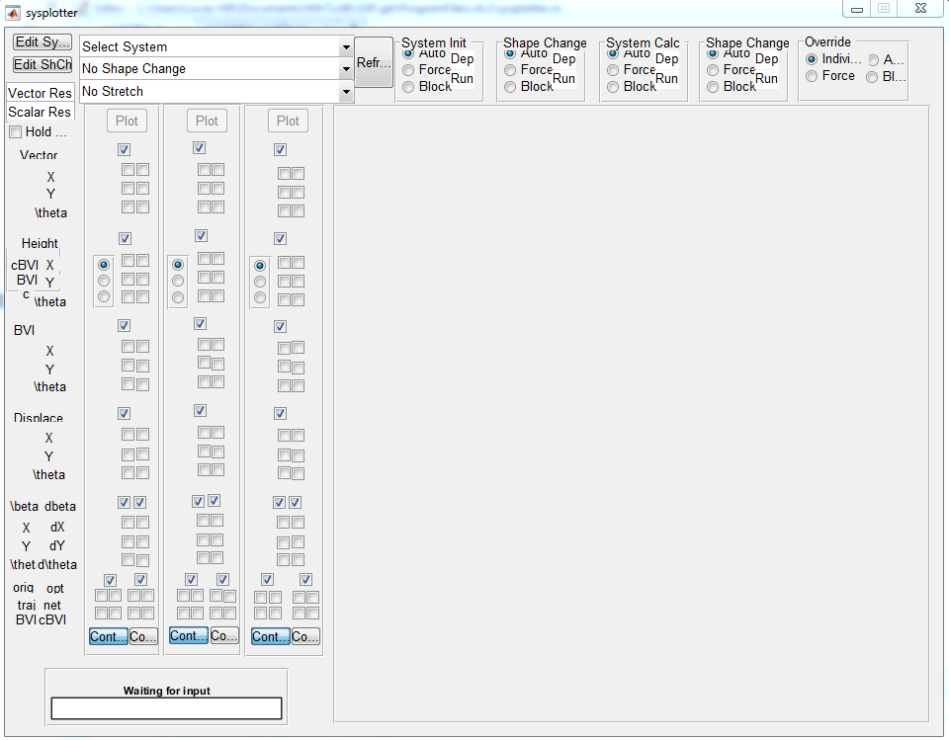

# Loading a System

1. Select the system you want to analyze from the “Select System” menu, e.g., the “3-link Viscous Swimmer”.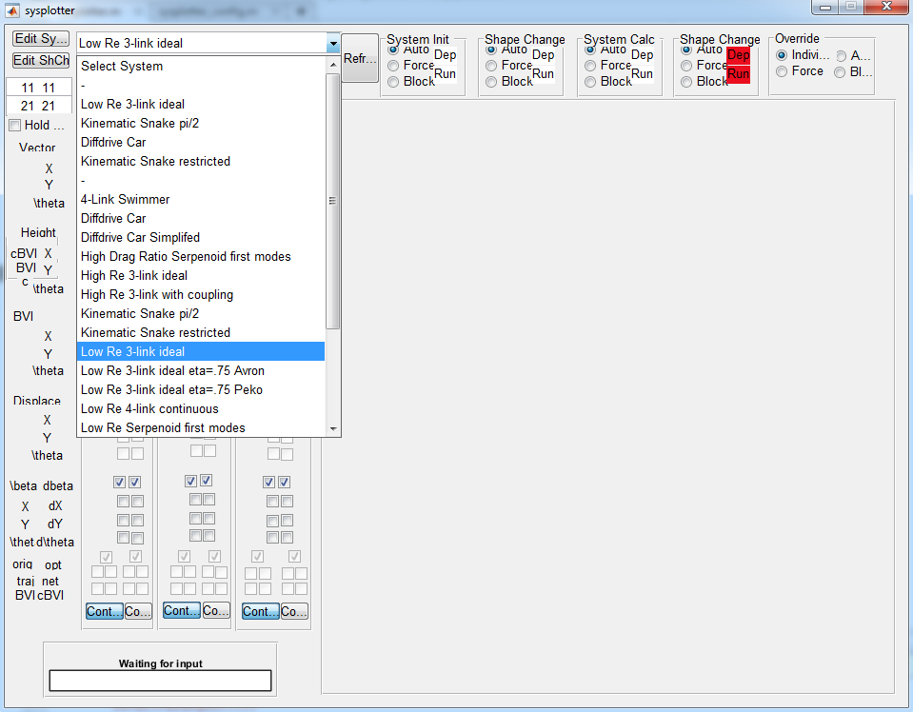
2. Next, select your “Shape Change”, we’ll use the “Circle Stroke, 1.0 amplitude”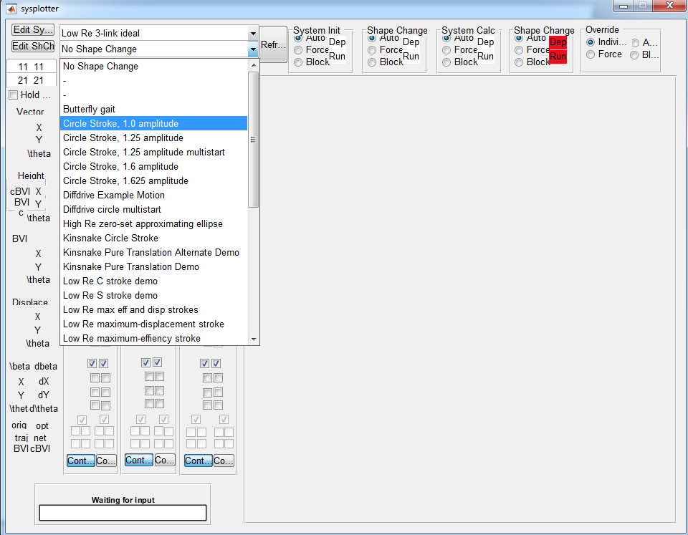
3. Ignore the “Stretch” menu for now
4. Now you’re ready to start plotting and analyzing.

# Plotting and Visualizing

Generate plots by selecting the corresponding checkboxes, then clicking the “plot” button. There are three sets of checkboxes (each with their own plot button), so that you can easily go back and forth between different sets of plots. 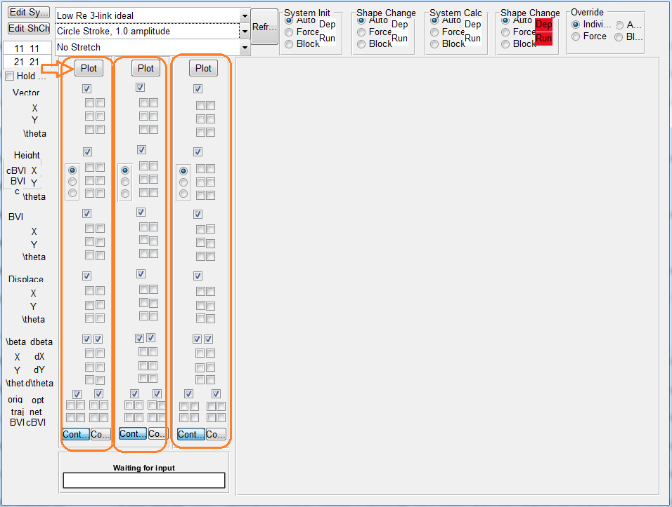

Each category of plots has a master-checkbox that toggles the whole block on and off 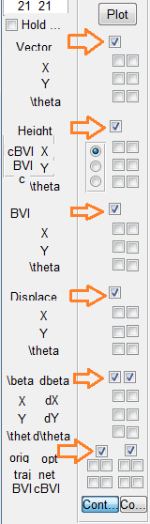

The Vector, Height function, BVI, and Displacement each have two columns; the left column plots the data exactly as it is specified in the system file, the right column plots it in the optimized coordinate system. Their three rows are their x, y, and theta components.

## Vector Fields

The “Vector” block plots the connection vector fields for the system, overlaid with the gait cycle selected. Here, all three fields are plotted in original coordinates

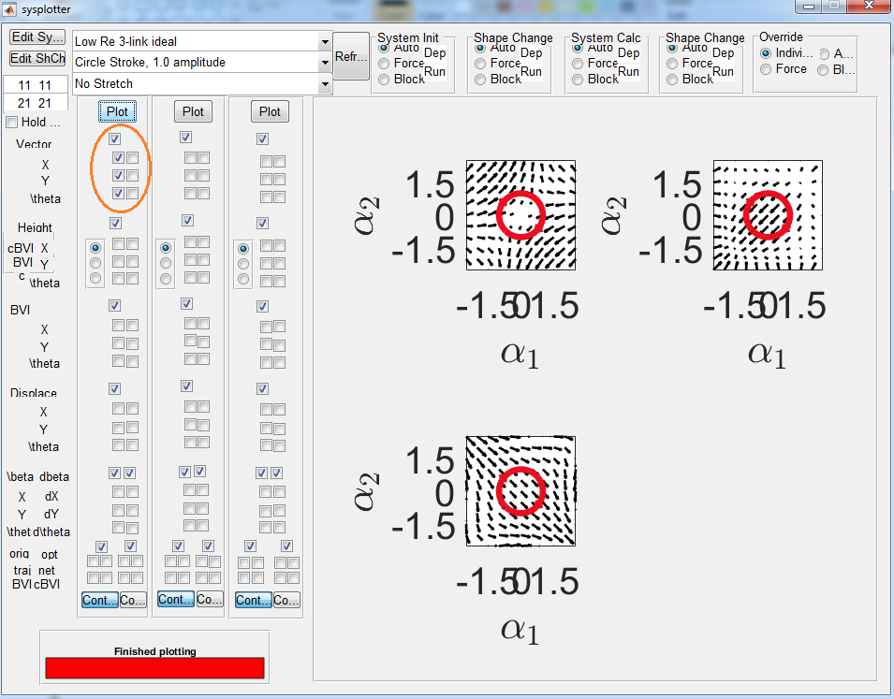

and here, the x component is plotted in original and optimized coordinates.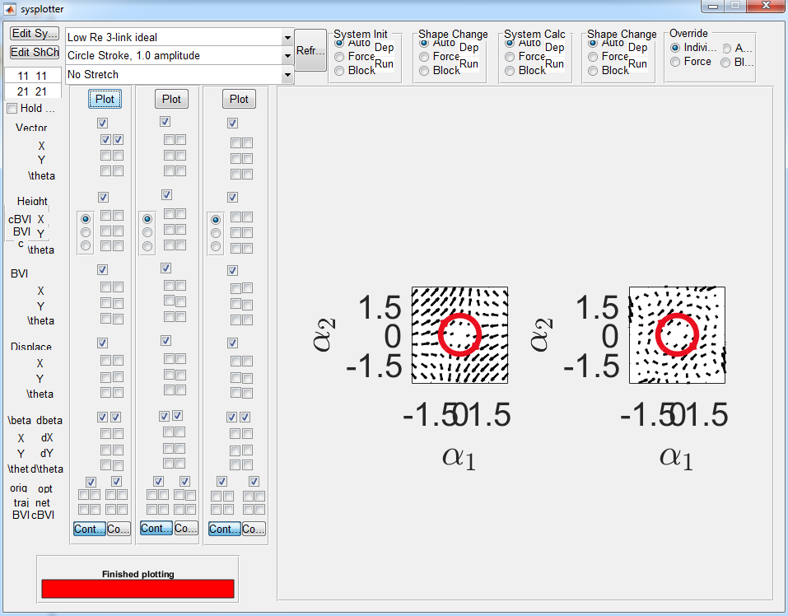

## Height Functions

The height functions work like the connection vector fields, except that there is a radio button for toggling between the height functions giving the cBVI (the total curvature, with both curl and Lie Bracket components), the BVI (curl only) and the correcting factor (the Lie bracket only).

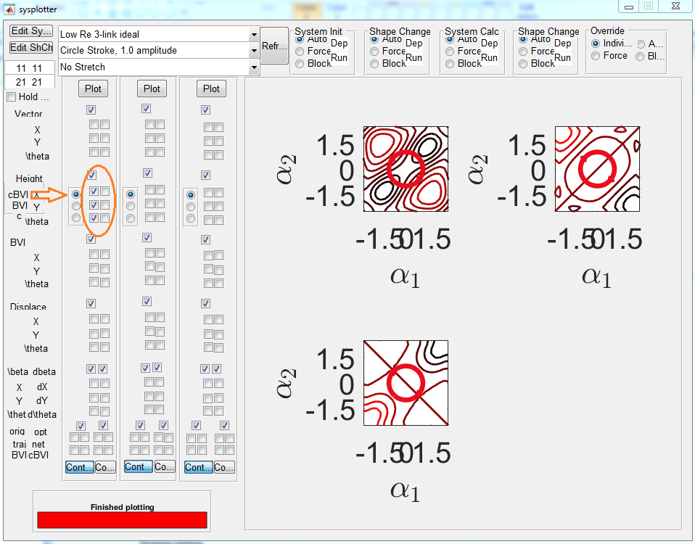

## BVI (Body-Velocity-Integral)

This block gives the time history of the BVI over the course of the gait (the cBVI is not defined over the course of the gait, so there is no option to display it) This display was included during development of the coordinate optimization (to show why it matters), and is probably not very useful any more.

## 

## Displacement

Time history of the x, y, and theta components of the displacement.

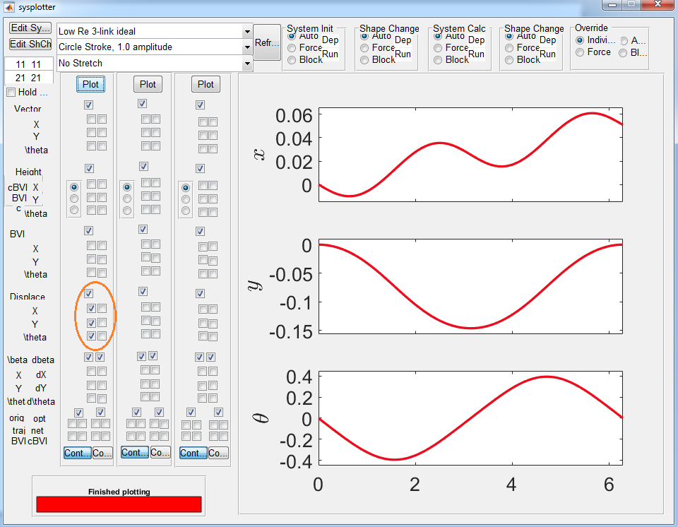

## Beta\

This shows the components of the transformation between original and optimal coordinates.

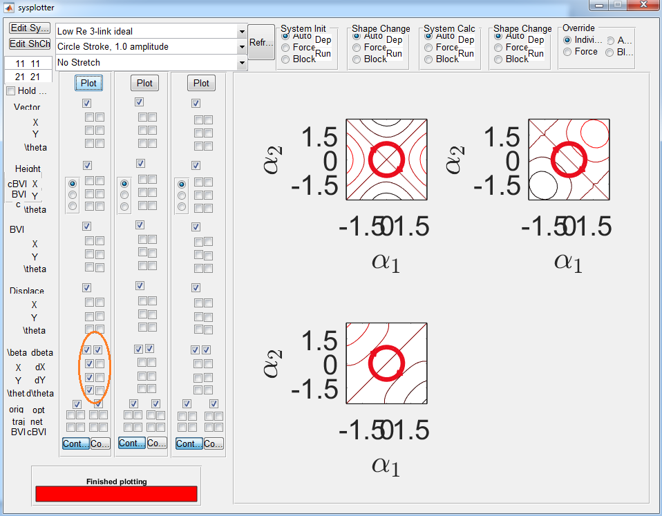

## Trajectories and Displacements

The bottom set of check operates somewhat differently from the rest. They are organized into two, 2x2 clusters. The image below, shows the trajectory taken by the original coordinate frame, and the estimate the BVI gives for the displacement. (Notice the error).

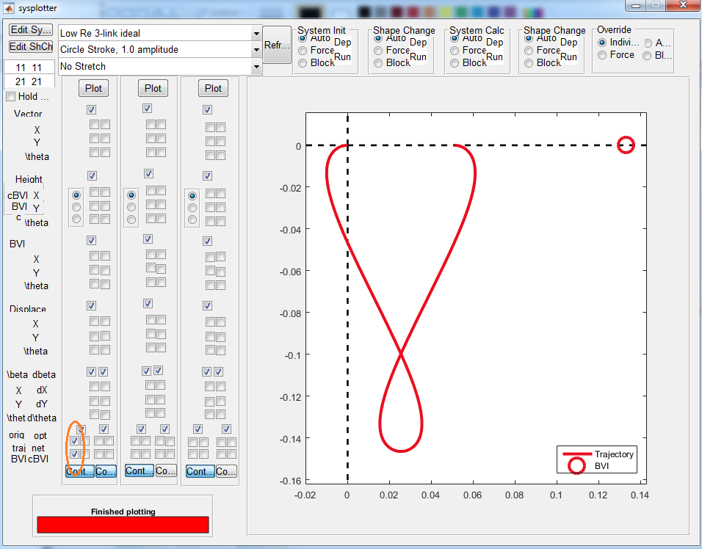

By adding the two check boxes to the right, we see the estimate given by the corrected-BVI.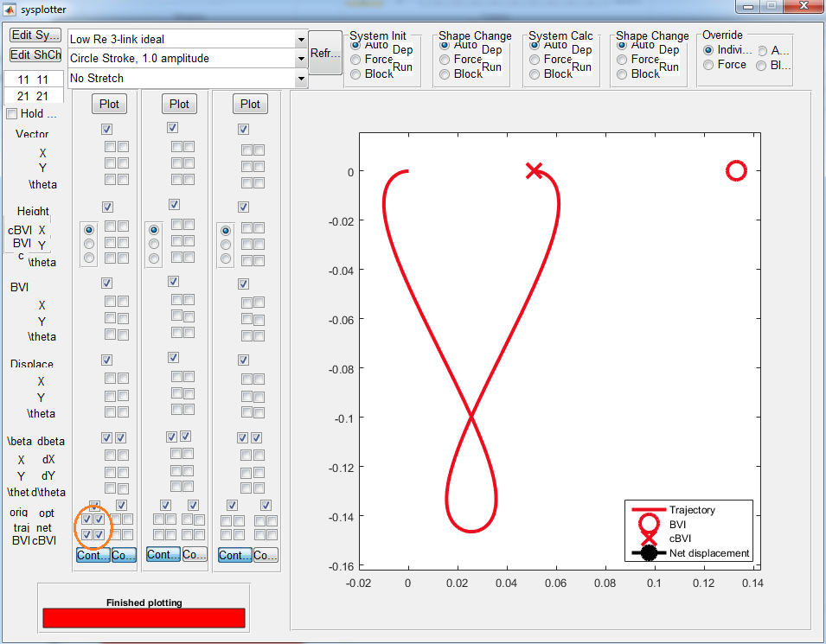

The other 2x2 cluster to the right shows the trajectory taken by the optimized coordinate, as well as the estimates from the BVI and cBVI.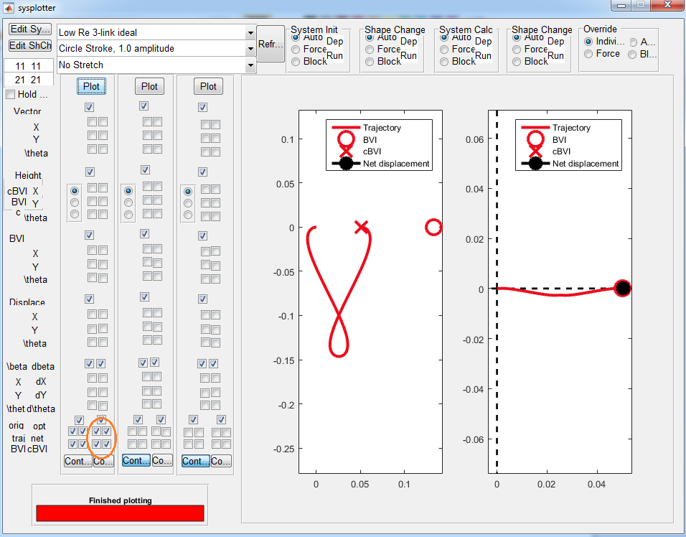

# Custom Closed-Gait Generation

1. Generate a height function.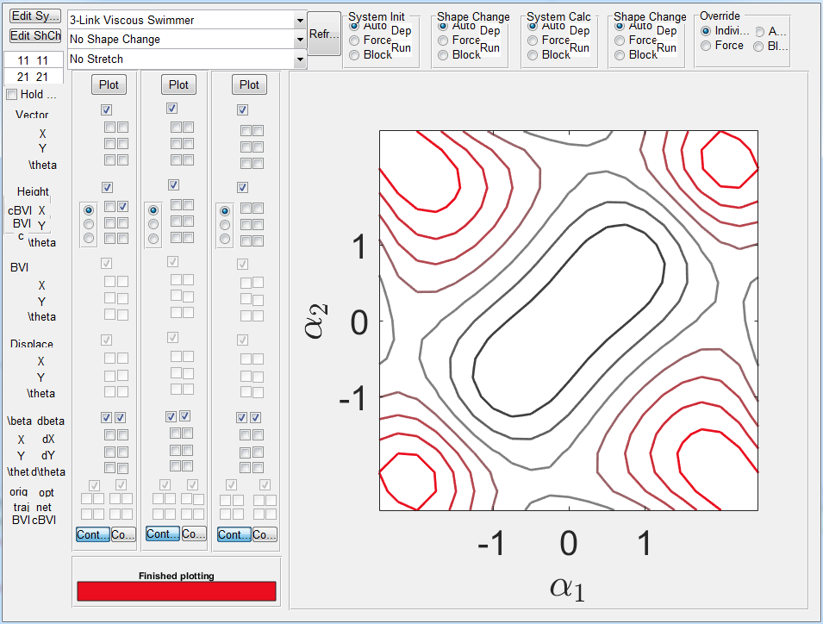
2. Click on one of the graphs to get an independent figure. 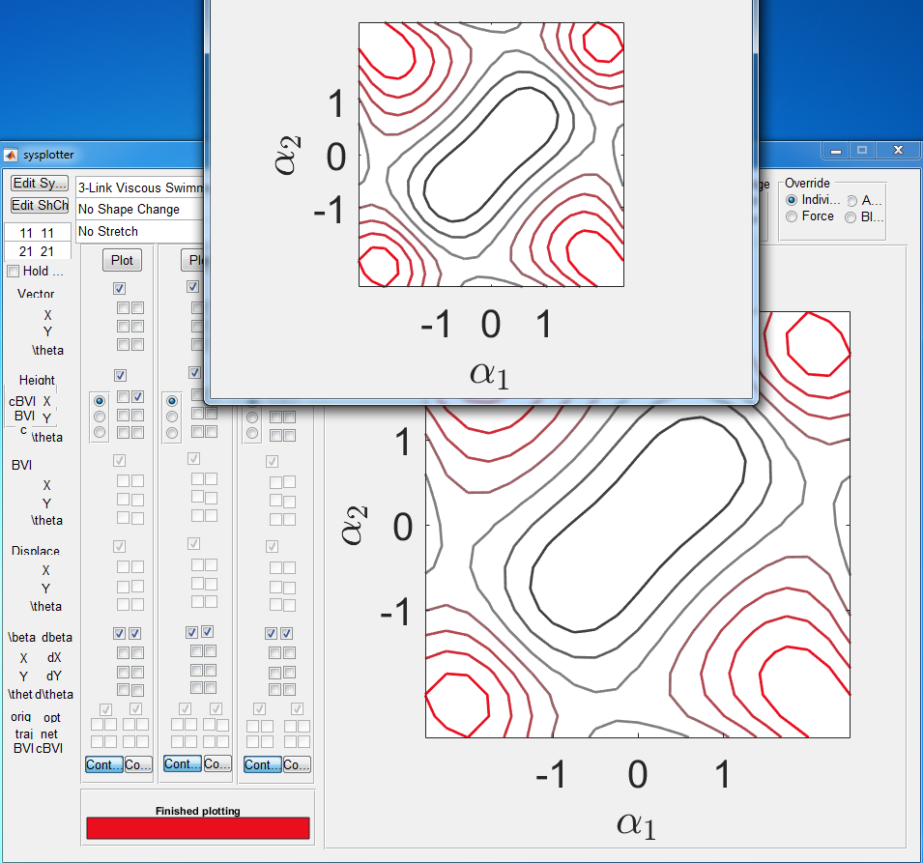
3. From the terminal in MATLAB, run “gait_gui_draw”.
4. Click on the independent figure of the height function to add points, 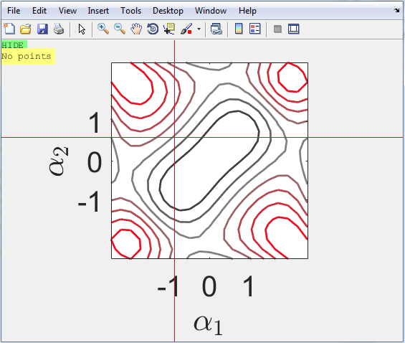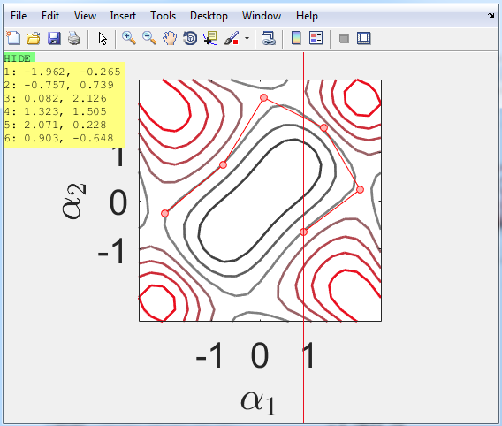 hit enter when done, a save dialog will appear to save your gait contour in your userfiles folder. Once that is done, the independent figure should show your gait, 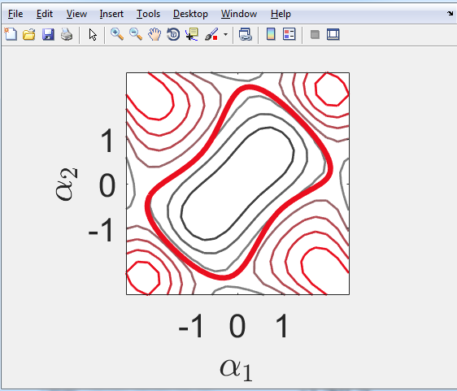
5. Now, in the sysplotter main gui, you can select your gait, through the Shape Change menu, 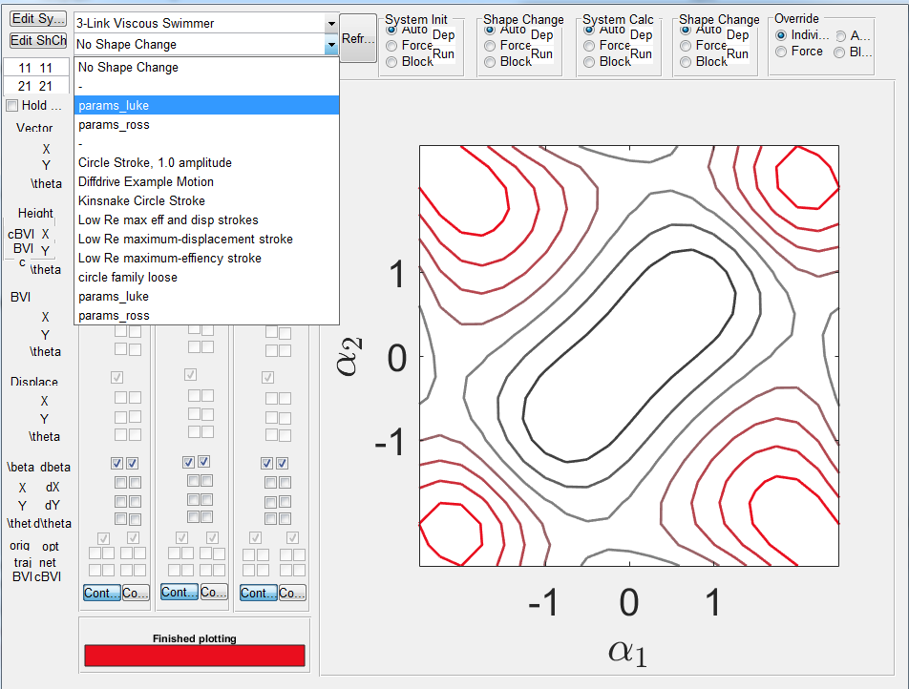

# Odds and Ends

Use this button to change the height function from contour to surface representations 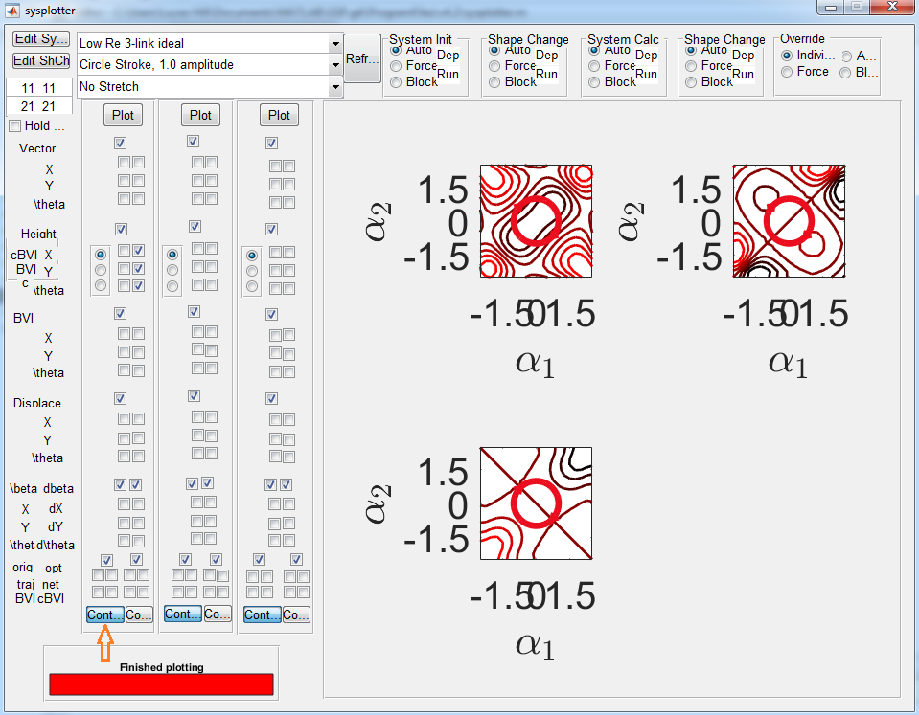

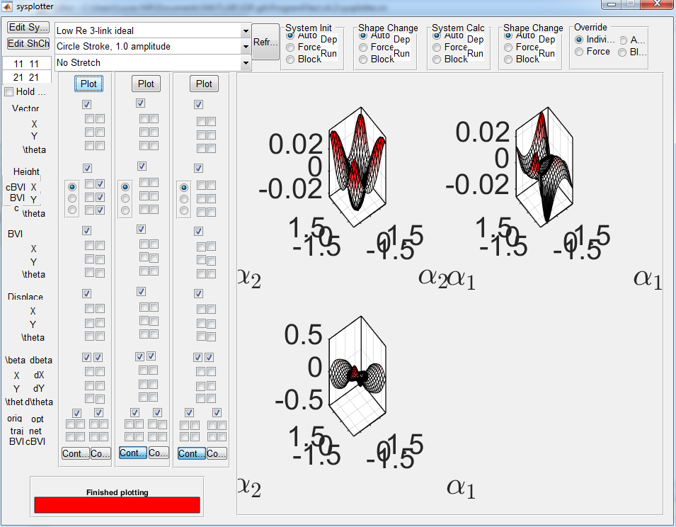

Also, all graphs can be clicked on to produce a single figure containing that graph. 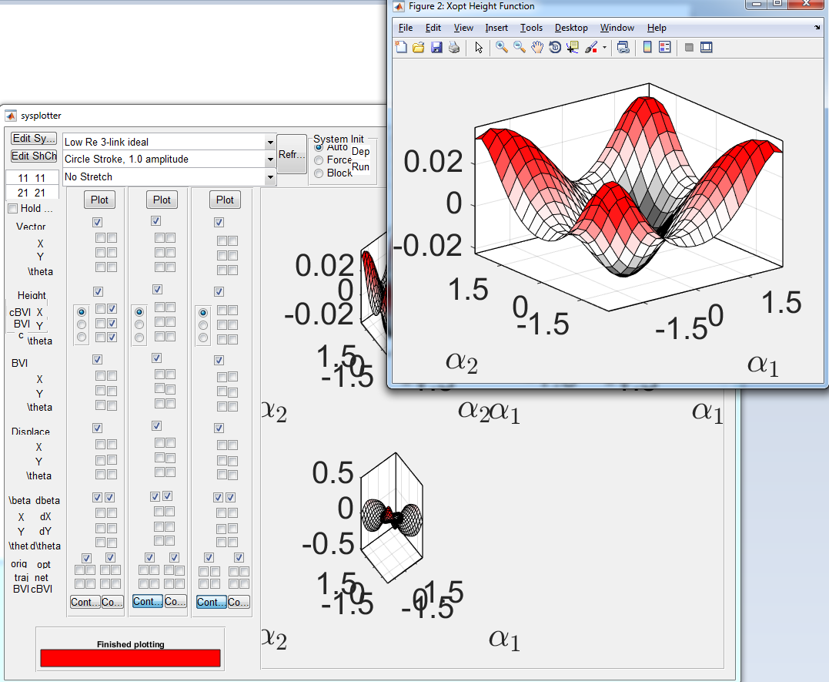

# Adding your own files

You can add new systems and shape changes to sysplotter by:

1. Clicking the “Edit” buttons to the left of the selection menus 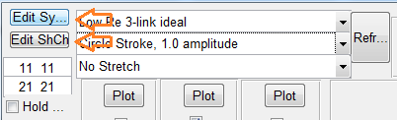
2. Saving a copy of the file into the appropriate directory. Make sure the file starts with sysf_ or shchf_ (system file or shape change file) so that sysplotter will recognize it
3. Changing lines of code in the file to get the behavior you want. Be sure to update the display name.
4. Click the Refresh button to the right of the selection menus to have the new file adopted into the menus.

